**DSA Assignment – 18th June**

**Name – Karan Joshi**

**Roll No. – 23/11/EC/036**

**Leetcode Id – Karan_Joshi068048**

**Geeksforgeeks Id – wwwjoshikaran3424**

**Github Repo Link -** [**https://github.com/KaranJoshi101/urban-octo-robot/**](https://github.com/KaranJoshi101/urban-octo-robot/)

DSA-Section -

Question 1: Two Sum

Platform: LeetCode

Problem Link: <https://leetcode.com/problems/two-sum/>

Submission Screenshot:

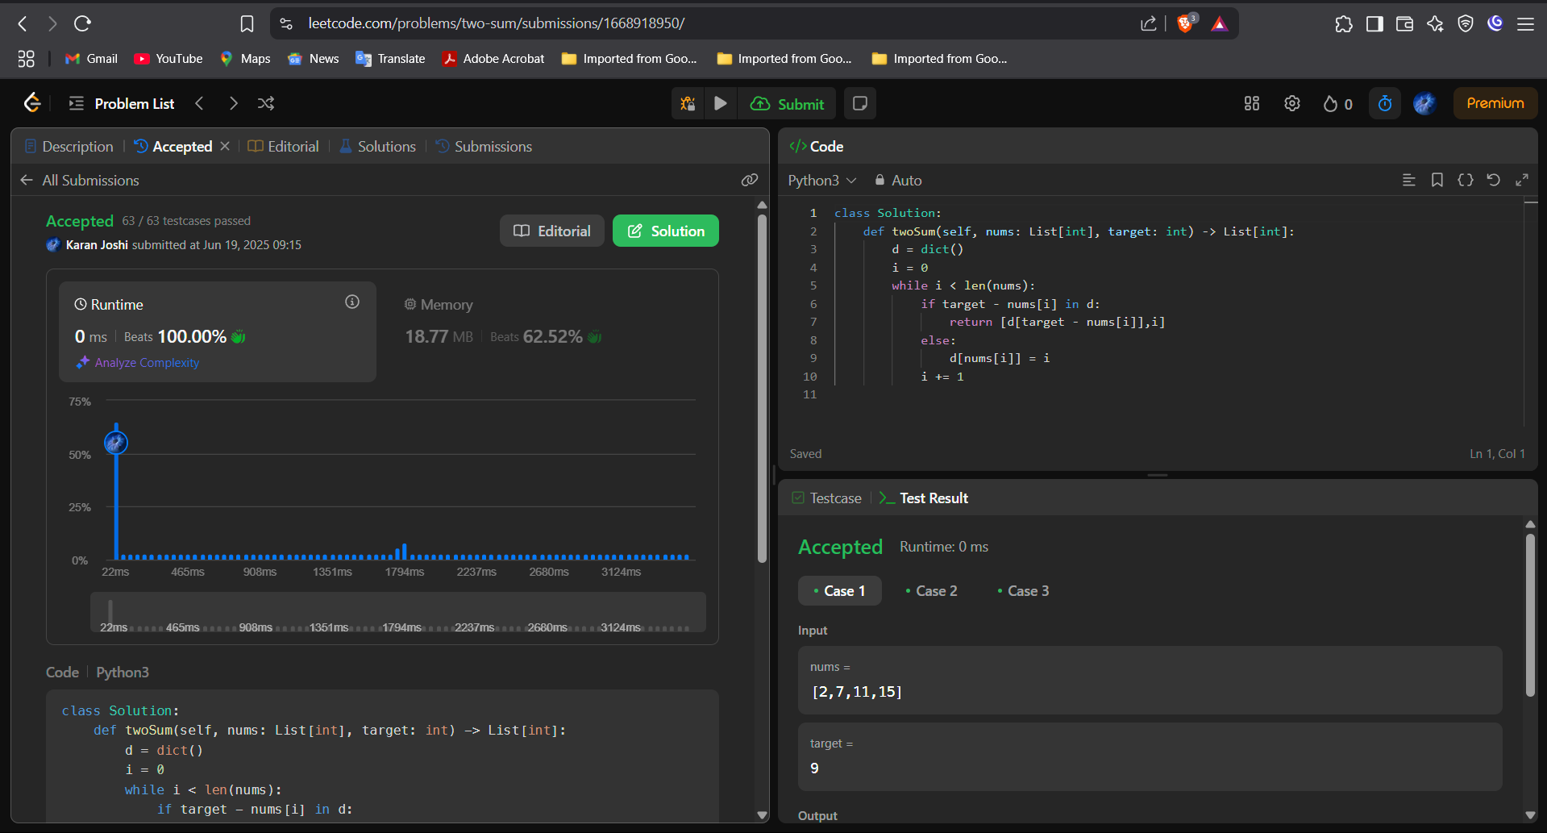

Question 2: Alone in Couple

Platform: GeeksforGeeks

Problem Link: <https://www.geeksforgeeks.org/problems/alone-in-couple5507/0>

Submission Screenshot:

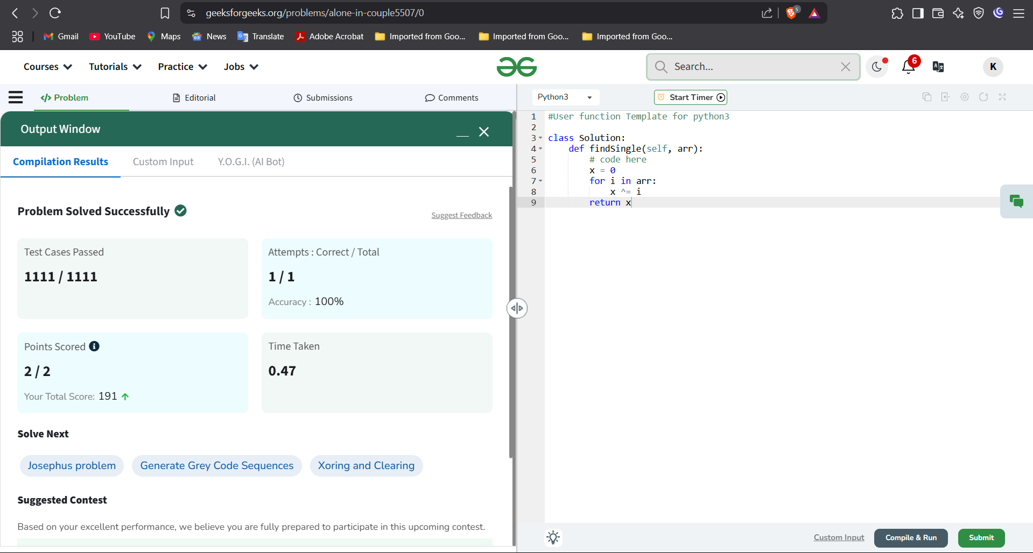

Question 3: Best Time to Buy and Sell Stock

Platform: LeetCode

Problem Link: <https://leetcode.com/problems/best-time-to-buy-and-sell-stock/>

Submission Screenshot:

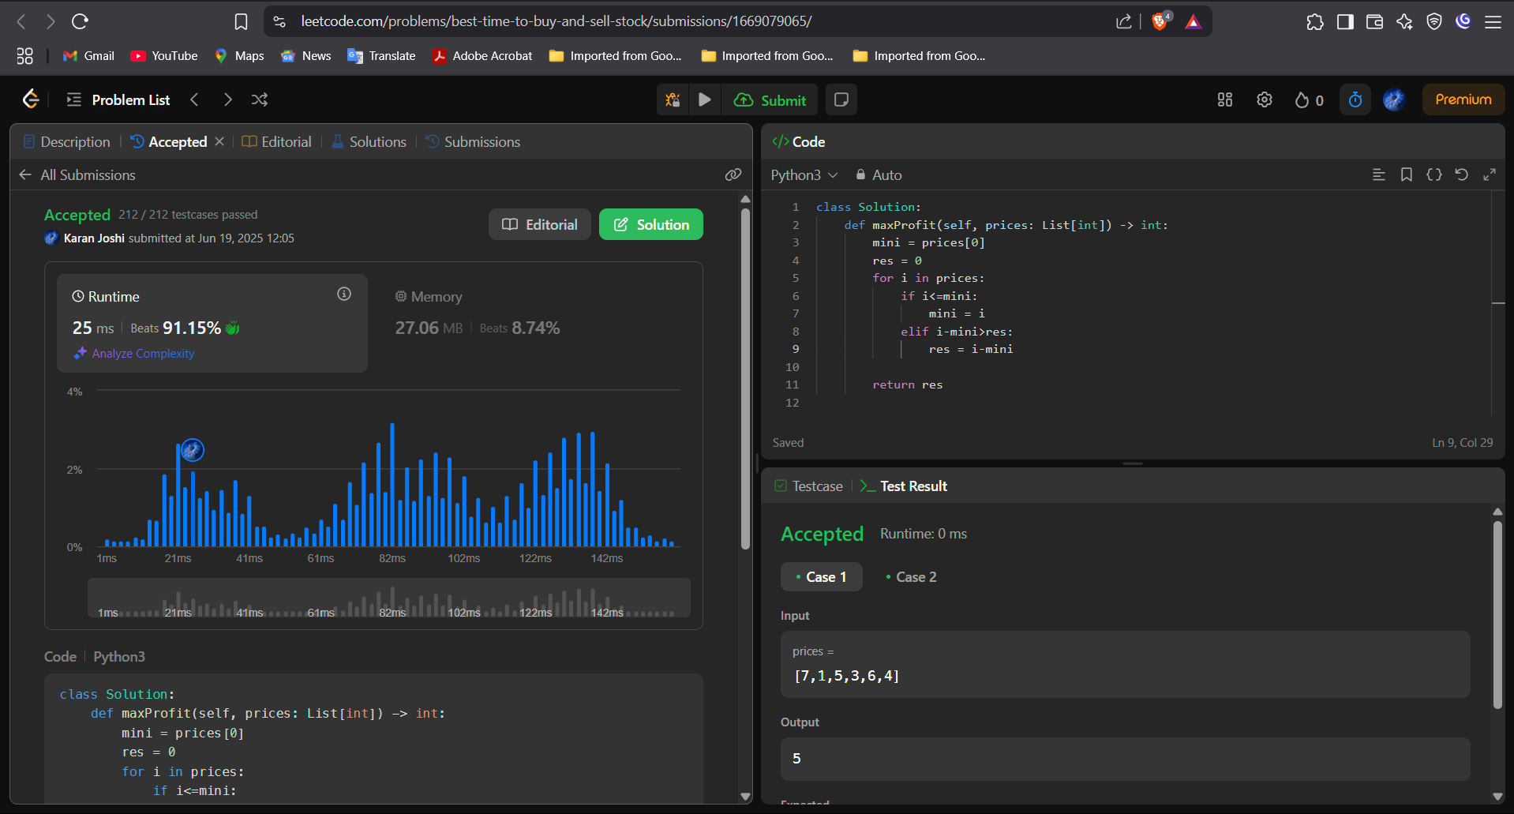



Question 4: Sort Colors

Platform: LeetCode

Problem Link: <https://leetcode.com/problems/sort-colors/>

Submission Screenshot:

